**Navy Food Security  
Scope Document**

Client  
Australian Defence Force – Royal Australian Navy  
Representative: Danny ____

Project Supervisor:

Project members:  
Kyana Bowers  
William Te

Contents

Version Control 3

Amendments 3

Project goals 4

Requirements 4

Major deliverables 5

Key milestones 5

Assumptions 5

Constraints 5

# Version Control

|  |  |  |  |
| --- | --- | --- | --- |
| Version number | Date | Author | Notes |
| 1.0 | 10/08/2021 | William Te | Document Created |
|  |  |  |  |

# Amendments

# Project goals

The scope of work for this document is to develop an application to bring the current situation in the Navy to a more modern efficient way. That is to change the process that is being currently implemented which is based on paper and convert it to a more modern technological means.

# Requirements

The client has requested an application that will allow users scan a qr code to collect information and fill details that is required by the HACCP Form (inserted below). The app will allow for creating orders, reading orders, update the order status, check for archived orders for the past 3 months.

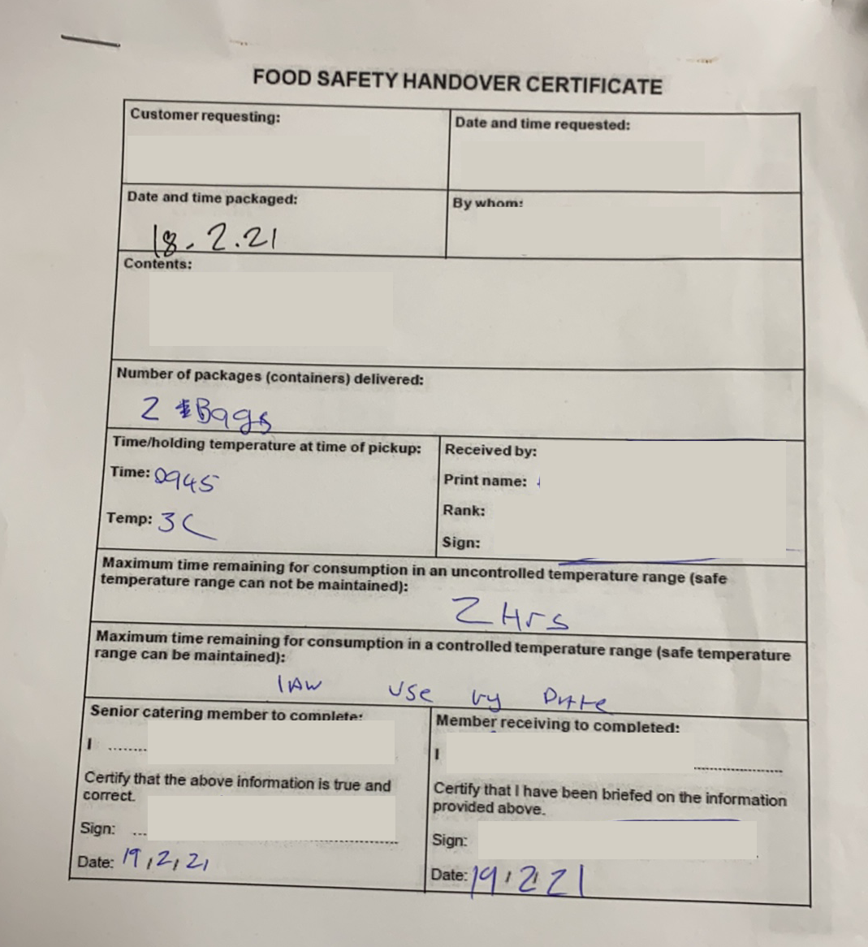

# Major deliverables

The main components that will be developed and provided to the client will be a mobile application website application, API and the database.

# Key milestones

Milestones in this project will be week 10 for the completion of all documentations. By week 17 the mobile app will be a Minimal Viable Product.

# Assumptions

The information that will be considered in this scope document is there will be legacy data that will be managed by the client.

There is no restriction to the coding language or the framework being used, nor deployment platform.

# Constraints

This project will be limited by the defined budget and peripherals present.

The software and hardware to run the application will be the standard military standard issue.

Specifications to come.